**Number Systems Used In Computers**

Complete the following table:

|  |  |  |  |
| --- | --- | --- | --- |
| **Number System** | **Number Base** | **Digits Used** | **Purpose** |
| Decimal | Base 10 | 0 to 9 | Used for communicating with human users |
| Binary |  |  |  |
| Octal |  |  |  |
| Hexadecimal |  |  |  |

**Decimal vs. Binary System**

Write down the definition of a **Bit** in computer terminology:

Complete the following table:

|  |  |  |
| --- | --- | --- |
|  | **Decimal System** | **Binary System** |
| Uses Digits |  |  |
| Addition Examples |  |  |
| Powers of 10 |  |  |
| Evaluate 111 |  |  |

**Powers of 2**

|  |  |  |  |  |
| --- | --- | --- | --- | --- |
| **Power  of 2** | **Decimal Value** | **Integer Range** | **Number  of Bits** | **Computer Binary** |
| 21 | 2 | 0 - 1 | 1 | 0001 |
| 22 | 4 | 0 - 3 | 2 | 0011 |
| 23 |  |  |  | 0111 |
| 24 |  |  |  | 1111 |
| 25 |  |  |  | 0001 1111 |
| 26 |  |  |  | 0011 1111 |
| 27 |  |  |  | 0111 1111 |
| 28 | 256 | 0 - 255 | 8 | 1111 1111 |
| 29 |  |  |  | 0001 1111 1111 |
| 210 |  |  |  | 0011 1111 1111 |
| 211 |  |  |  | 0111 1111 1111 |
| 212 |  |  |  | 1111 1111 1111 |
| 213 |  |  |  | 0001 1111 1111 1111 |
| 214 |  |  |  | 0011 1111 1111 1111 |
| 215 |  |  |  | 0111 1111 1111 1111 |
| 216 | 65,536 | 0 – 65,535 | 16 | 1111 1111 1111 1111 |

**Conversions**

Convert the following binary numbers to decimal:

11 binary =

101 binary =

1010 binary =

Convert the following decimal numbers to binary:

6 decimal =

13 decimal =

**Binary Addition**

Add the following binary numbers. (verify your answers using decimal)

|  |  |  |  |  |  |  |  |  |  |  |  |  |  |
| --- | --- | --- | --- | --- | --- | --- | --- | --- | --- | --- | --- | --- | --- |
| |  |  | | --- | --- | | **0101** | **(decimal 5)** | | **+ 0010** | **(decimal 2)** | |  |  | | |  |  | | --- | --- | | **0101** | **(decimal 5)** | | **+ 1010** | **(decimal 10)** | |  |  | |
| |  |  | | --- | --- | | **0011** | **(decimal 3)** | | **+ 0010** | **(decimal 2)** | |  |  | | |  |  | | --- | --- | | **0110** | **(decimal 6)** | | **+ 0011** | **(decimal 3)** | |  |  | |

**Prefixes**

* Kilo (K) means __________________ Multiply by x______________
* Mega (M) means _________________ Multiply by x______________

* Giga (G) means __________________ Multiply by x______________
* Tera (T) means __________________ Multiply by x______________

**Examples**

1. 64 Kbps (Kilo-bits per seconds) = ___________________ bps (bits per second)
2. 256 Giga-bytes = _________________________________ bytes
3. 256 Giga-bytes = _________________________________ bits

**Computer Memory Structures**

|  |  |  |  |
| --- | --- | --- | --- |
| **Structure** | **Number of Bits** | **Largest Value** | **Used For...** |
| Bit |  |  |  |
| Byte |  |  |  |
| Word |  |  |  |
| Short Integer |  |  |  |
| Double Word |  |  |  |
| Long Integer |  |  |  |
| Memory Address |  |  |  |

**Memory Organization**

Bit (Binary Digit)

* One bit can have a value of ________ or _________
* Or a Boolean logic value of ________ or _________

|  |  |  |  |  |  |  |  |  |  |  |  |  |  |  |  |  |  |  |  |
| --- | --- | --- | --- | --- | --- | --- | --- | --- | --- | --- | --- | --- | --- | --- | --- | --- | --- | --- | --- |
| |  |  |  |  | | --- | --- | --- | --- | | 0 | 0 | 0 | 0 | | |  |  |  |  | | --- | --- | --- | --- | | 0 | 0 | 0 | 0 | | |  |  |  |  | | --- | --- | --- | --- | | 0 | 0 | 0 | 0 | | |  |  |  |  | | --- | --- | --- | --- | | 0 | 0 | 0 | 0 | |

Byte (8 bits)

* One byte has a size of ________ bits
* A byte has an unsigned integer value range from 0 to _________

|  |  |  |  |  |  |  |  |  |  |  |  |  |  |  |  |  |  |  |  |
| --- | --- | --- | --- | --- | --- | --- | --- | --- | --- | --- | --- | --- | --- | --- | --- | --- | --- | --- | --- |
| |  |  |  |  | | --- | --- | --- | --- | | 0 | 0 | 0 | 0 | | |  |  |  |  | | --- | --- | --- | --- | | 0 | 0 | 0 | 0 | | |  |  |  |  | | --- | --- | --- | --- | | 0 | 0 | 0 | 0 | | |  |  |  |  | | --- | --- | --- | --- | | 0 | 0 | 0 | 0 | |

Word (2 bytes or 16 bits)

* One word has a size of ________ bits
* One word has a size of ________ bytes
* A byte has an unsigned integer value range from 0 to _________

|  |  |  |  |  |  |  |  |  |  |  |  |  |  |  |  |  |  |  |  |
| --- | --- | --- | --- | --- | --- | --- | --- | --- | --- | --- | --- | --- | --- | --- | --- | --- | --- | --- | --- |
| |  |  |  |  | | --- | --- | --- | --- | | 0 | 0 | 0 | 0 | | |  |  |  |  | | --- | --- | --- | --- | | 0 | 0 | 0 | 0 | | |  |  |  |  | | --- | --- | --- | --- | | 0 | 0 | 0 | 0 | | |  |  |  |  | | --- | --- | --- | --- | | 0 | 0 | 0 | 0 | |
|  | |  | |

Long or Double Word (4 bytes or 32 bits)

* One Long word has a size of ________ words
* A Long word has an unsigned integer value range from 0 to _________

|  |  |  |  |  |  |  |  |  |  |  |  |  |  |  |  |  |  |  |  |
| --- | --- | --- | --- | --- | --- | --- | --- | --- | --- | --- | --- | --- | --- | --- | --- | --- | --- | --- | --- |
| |  |  |  |  | | --- | --- | --- | --- | | 0 | 0 | 0 | 0 | | |  |  |  |  | | --- | --- | --- | --- | | 0 | 0 | 0 | 0 | | |  |  |  |  | | --- | --- | --- | --- | | 0 | 0 | 0 | 0 | | |  |  |  |  | | --- | --- | --- | --- | | 0 | 0 | 0 | 0 | |
|  | |  | |
| |  |  |  |  | | --- | --- | --- | --- | | 0 | 0 | 0 | 0 | | |  |  |  |  | | --- | --- | --- | --- | | 0 | 0 | 0 | 0 | | |  |  |  |  | | --- | --- | --- | --- | | 0 | 0 | 0 | 0 | | |  |  |  |  | | --- | --- | --- | --- | | 0 | 0 | 0 | 0 | |
|  | |  | |

**Questions**

1. What is the smallest memory object that can represent a character of information?
   1. Think… How many upper case letters in the alphabet (A to Z)?’’

26

* 1. Think… How many lower case letters in the alphabet (a to z)?

26

* 1. Think… How many number digits (0 to 9)?

10

* 1. Think… How many punctuation marks?

14

* 1. Add them all up

76 keys

1. Research the ASCII characters set. What is it and how is it related to computer memory?

ASCII is how computers communicate in English and how the computer uses numbers this is related in computer memory because the computer puts stuff in the memory using numbers and ASCII is how the computers use.

1. How are strings of characters (Google “String”) represented in computer memory?

Characters are normally represented as strings of seven bits each in ASCII. There are seven in computer memory.

1. How are negative integers represented in computer memory? (Include a diagram)

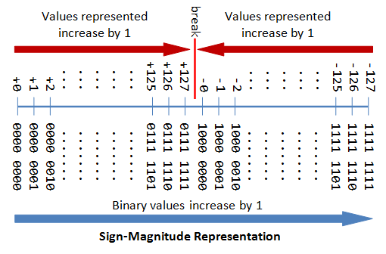

Negative integers are represented in computer memory because the computer needs to understand the knowledge that it is getting so the negative integers are helping that by minusing the knowledge that it does not need

1. How are decimal numbers (Google “Floating Point”) represented in computer memory? (Include a diagram)

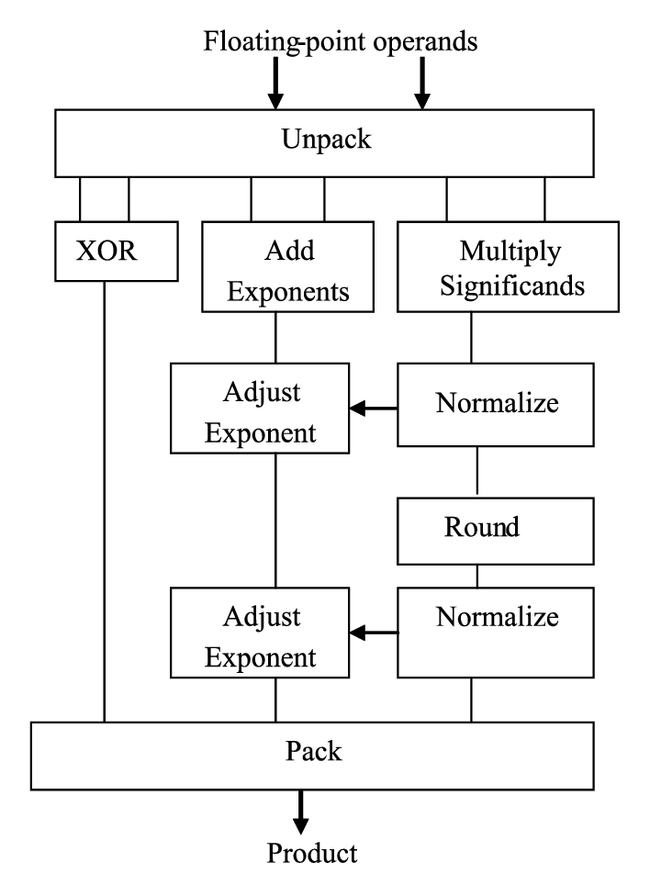

Floating point is represented in computer memory because the floating point helps the computer find out what numbers that the computer needs to use.

1. A Pixel is computer memory structure used to store image information. How is a Pixel represented in memory? (Include a diagram).

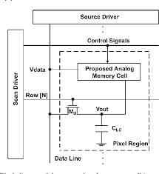

A pixel is represented in computer memory because pixels are how we can see what is on the computer.